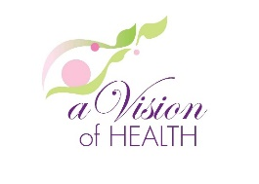
SoroFest 2016 Community Festival brings you…

NO COST Mammography Screenings!
(No cost for those who qualify. Most insurance also accepted, no HMO)
*Make sure to bring your medical insurance card with you*
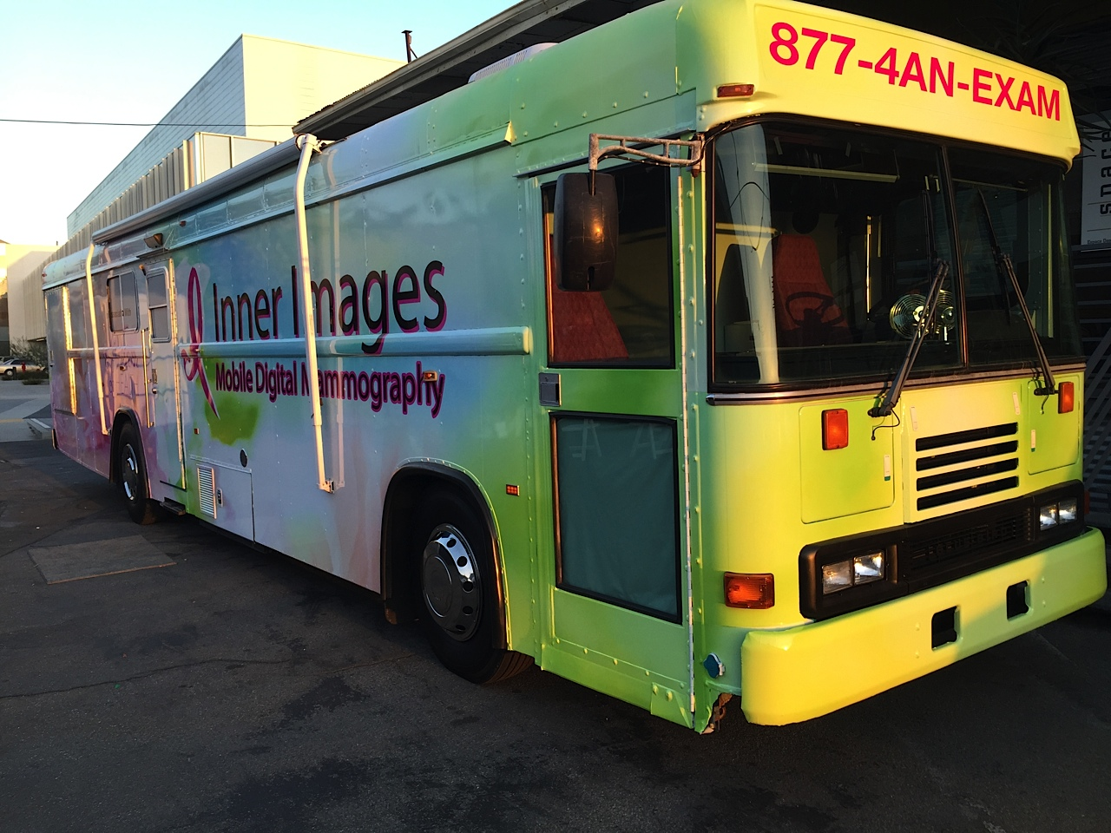Don’t miss your chance to get screened on Los Angeles’ first digital mammography coach!

Sunday, June 5th from 11:00AM – 4:00PM
2613 S Robertson Blvd.
Los Angeles, CA 90034
Call (877) 4AN-EXAM or visit www.mammo123.com for eligibility and to schedule your appointment
*Walk-ins are welcomed*

