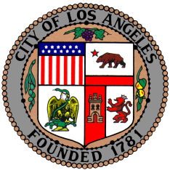
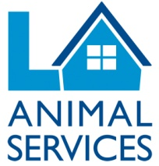
LOS ANGELES
ANIMAL SERVICES

FOR IMMEDIATE RELEASE

Contact Information
Sara Ebrahimi
sara.ebrahimi@lacity.org
(213) 482-9551

LA Animal Services Seeks Community Input

Los Angeles Animal Services seeks input from the community to help plan a future in which they can do even more for animals and people in the City of LA
Los Angeles, CA, March 10, 2016 – The City of Los Angeles Department of Animal Services is collaborating with the Mayor’s office, the Board of Animal Services Commissioners, a third party consultant, and Angelenos to produce a shared vision and action plan to continue improving the welfare and safety of animals and people in the City of LA.

In order to develop a comprehensive plan, there will be fifteen community meetings from March 2016 through May 2016 with one in each Council District. Residents do not have to be a pet owners or animal lovers to attend one of these community meetings. All residents are encouraged to come ask questions and share ideas on how LA Animal Services can do more for animals and people in the community.

“The communities of Los Angeles are critical part of our planning process,” said Brenda Barnette, general manager for LA Animal Services. “We are seeking the support and valued input of community members to help save the lives of more animals and better serve the neighborhoods in our City. We look forward to this process to assist with the future priorities and goals of the Department of Animal Services.”

Los Angeles Animal Services is working to become the largest no-kill city in the nation. In Fiscal Year 2011-2012, the live-save rate for shelter impounds was only 57.8% and today, as of January 2016, the live-save rate is at 78.2%. The City operates six animal shelters: East Valley, West Valley, Harbor, North Central, South Los Angeles, Chesterfield Square, and West Los Angeles.

For more information on LA Animal Services community meetings and action plan, please visit laanimalservices.com.

Department of Los Angeles Animal Services
LA Animal Services is one of the largest municipal shelter systems in the United States with six shelters serving approximately 60,000 animals annually and responding to 20,000 emergency calls involving an animal or person in danger. LA Animal Services promotes and protects the health, safety and welfare of animals and people.

To become a fan on Facebook go to: www.facebook.com/LAAnimalServices/
Follow on Twitter: twitter.com/lacitypets

###

